**Generating sample data for Octree testing**

A spherical point cloud can be generated as

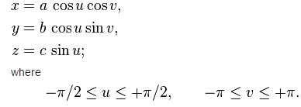

a = b = c = R * rand()